Mitchell "Newt" Favarote

Sunday, November 1, 1936 - Tuesday, August 24, 2021

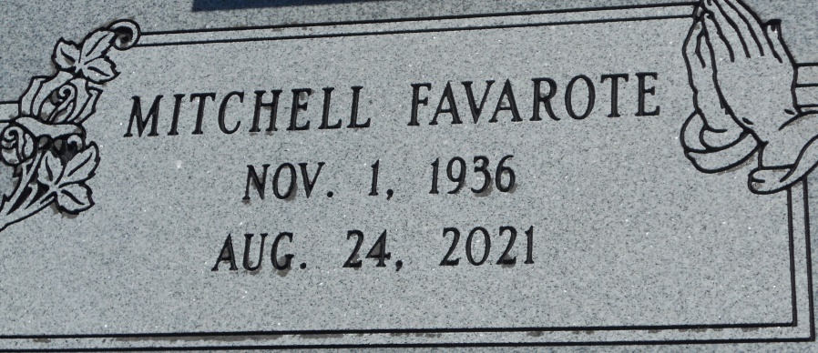

Photo by Team T Lo

Mitchell Favarote was born on November 1, 1936 to the late Joseph Favorite and Marent Mitchell Favorite. He entered eternal life peacefully on Tuesday, August 24, 2021 at the age of 84.  
 Mitchell Favarote, was a resident of Chateau St. James Rehab & Retirement Home in Luther, LA. Before retiring, he lived and worked as a licensed electrician in Los Angeles, CA for over 40 years. Mitch or Uncle Newt, as he was affectionately known, was a quiet and gentle spirit that enjoyed family and family gatherings.  
 He leaves to cherish his memories three sisters, Stella Jasmin (the late Alvin), Genevieve Keller (Edmond Jr.) of Los Angeles, CA, and Rita Herbert (Dinnel) of Wallace LA; two brothers, Joseph (Herman) Favarote (Mercidee) of New Orleans, LA and Murry Favorite of Los Angeles, CA; one sister-in-law, Elouise Favorite (the late Robert) of New Orleans, LA; his Godchildren, Regina Favarote and Cecile Adams, and a host of nieces, nephews, cousins, relatives and friends.  
 He was preceded in death by his parents, Joseph and Marent Favorite; two brothers, Robert Favorite and Eunice Favarote, and one sister Ruth Favorite Dumas.  
 A public walk-through visitation will be held on Saturday, August 28, 2021 from 10am – 10:30am at Treasures of Life Funeral Services, 315 E Airline Hwy., Gramercy, LA 70052. A graveside ceremony will be held on Saturday, August 28, 2021 at St. Phillip Catholic Church Cemetery in Vacherie, LA. Services will begin at 11am. Final care and professional services entrusted to Treasures of Life Funeral Services.  
 The family of Mitchell Favarote would like to thank the staff of Chateau St. James Rehab & Retirement Home for their care of our loved one. We also extend heartfelt thanks to all for the love, prayers and support shown to us during our time of loss.

Treasures of Life Funeral Services, Gramercy, Louisiana